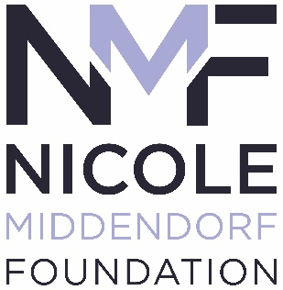
Annual Luncheon
Friday, October 14, 2022

Sponsorship Registration

Sponsor Name:____________________________________________________________________________________

Contact Name:____________________________________________________________________________________

Address:_________________________________________________________________________________________

City, State, Zip:___________________________________________________________________________________

Phone:____________________________________ Email: ________________________________________________

Sponsorship Packages

_____ Platinum Sponsor $3,000 _____ Gold Sponsor $2,000 _____ Silver Sponsor $1,500

_____ Table Sponsor $550 _____ Wall of Wine Sponsor $500

Payment

Check enclosed (Payable to The Nicole Middendorf Foundation)

Credit Card (Enter information below or register at www.nicolemiddendorf.com)

Circle One: MasterCard VISA Discover American Express

Name on Credit Card:_______________________________________________________________________________

Card Number:___________________________________________ Exp. Date:_____________ Security Code:________

Billing Address (if different than above)_________________________________________________________________

City, State, Zip:____________________________________________________________________________________

Cardholder’s Signature:______________________________________________________________________________

Please return to: Attn: Janiecea Tyson, Prosperwell Financial, 4300 Baker Road Minnetonka, MN 55343

For more information contact hello@nicolemiddendorf.com

